**How to destroy RNase**

<http://www.lifetechnologies.com/order/catalog/product/AM9780>

**RNase*Zap*® RNase Decontamination Solution** (Ambion®)

[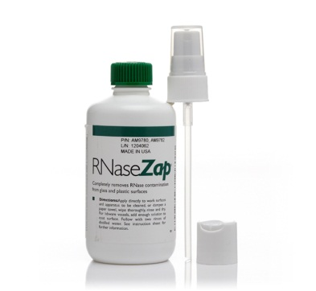](http://www.lifetechnologies.com/order/catalog/product/AM9780) 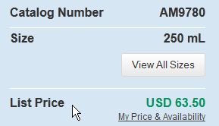

**Description**

RNase*Zap*® RNase Decontamination Solution is a surface decontamination solution that destroys RNases on contact. **You simply spray RNaseZap® Solution onto the surface to be decontaminated and rinse it off with RNase-free water.**  
  
Features of RNase*Zap*® RNase Decontamination Solution:  
  
• Completely removes RNase contamination from glass and plastic surfaces  
• Excels at removing high levels of RNase contamination whereas similar products fail  
• Proven effective at removing high concentrations of dried-on RNase A  
• Ideal for cleaning work surfaces, pipettors, and equipment that must be RNase-free  
  
**Using RNase*Zap*® Solution**  
Working with RNA requires that special measures be taken to ensure an RNase-free environment. Even trace quantities of RNase can lead to lower yields from *in vitro* transcription reactions, degradation during RNA purification protocols, and variable results in RPAs and Northerns. RNaseZap® contains three ingredients active against RNase and has proven to…

http://www.faqoverflow.com/biology/8246.html